Install AVR ver.7

1. Restore AvrServiceDatabase.bak to your db instance.

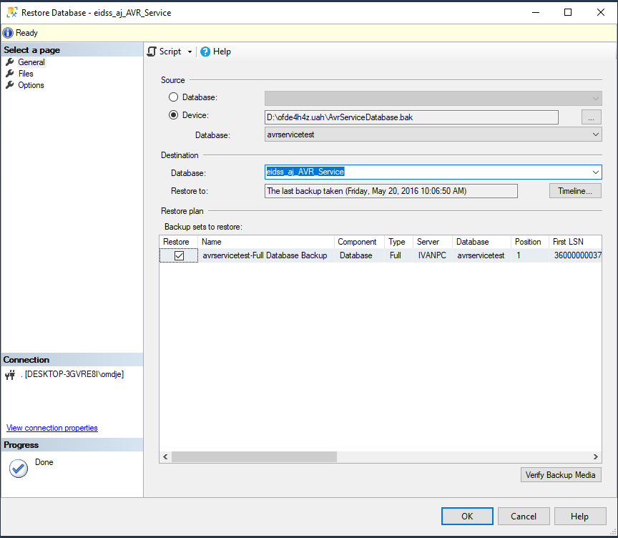

In the screen shot above, AvrServiceDatabase.bak has been restored as eidss_aj_AVR_Service

1. Proceed with the installation of AVR by running EIDSS.AVRService

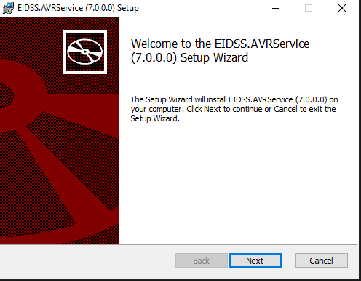

Accept the license agreement to proceed

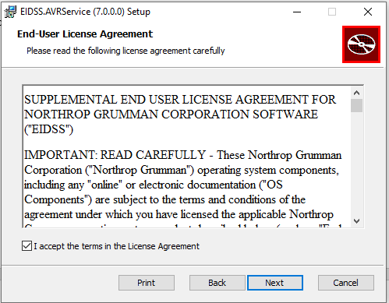

Choose your installation folder

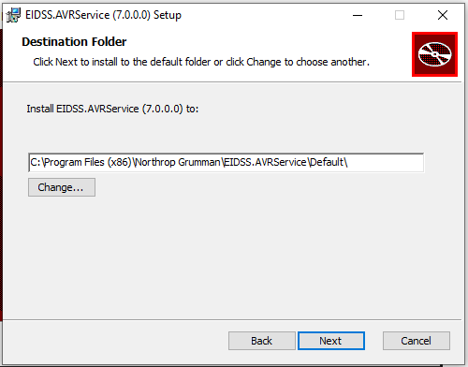

Specify Scheduler Configuration

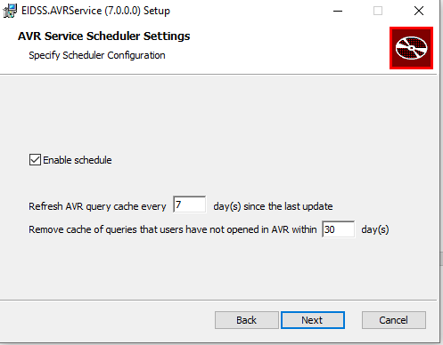

Specify the scheduler configuration

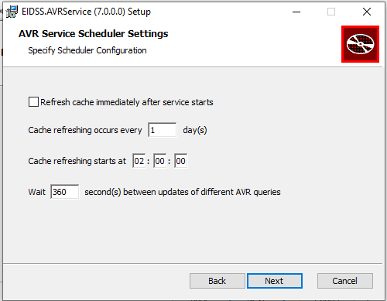

Specify your database connection settings

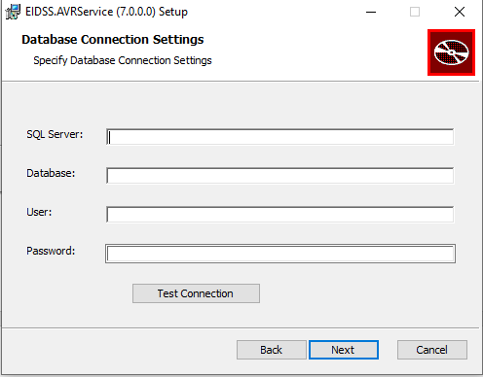

Specify the archive database connection settings

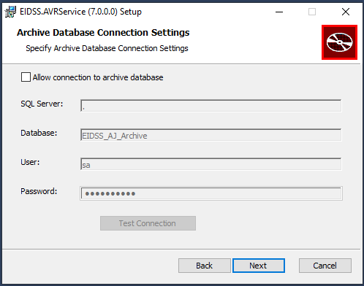

Specify the AVR Service database connection settings (the restored database)

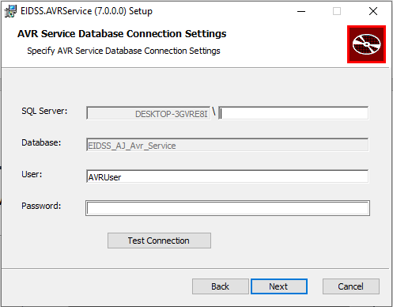

Specify AVR Service Settings

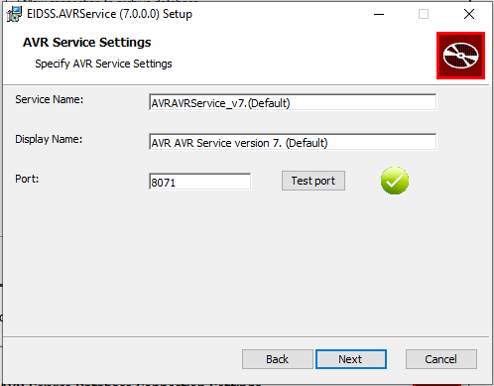

You are now ready to proceed with the install by clicking the Install button

